WELCOME TO YOUR APPRENTICESHIP



CONTENTS | PAGE
Who’s who? | 4
The Learning Process | 5
e-Safety | 10
Equality and Diversity | 11
Citizenship & British Values | 13
Data Protection | 14
Safeguarding | 15
Health & Safety | 17
Safety and Wellbeing Contact List | 18

WHO’S WHO?

TRAINERS/ COACHES

Trainers / Coaches deliver the workshops you will attend during your apprenticeship. The workshops will include various methods of teaching and learning that will help to embed and assess your knowledge and skills against the apprenticeship standards. They are responsible for assessing your work and determining if you have achieved the required standards.

INTERNAL QUALITY ASSURERS (IQA)

IQAs ensure that the assessment decisions made by your trainer are accurate and fair and can also offer support and advice to both you and your trainer.

OFQUAL (OFFICE OF QUALIFICATIONS AND EXAMINATIONS REGULATION)

Ofqual regulates qualifications, examinations and assessments in England.

END POINT ASSESSORS (EPA)

EPA’s visit training providers towards the end of the qualification and will conduct the required final assessment of Knowledge, Skills and Behaviors and will determine the overall result of the work presented at the end of the qualification (Fail, Pass, Distinction) based on evidence of work presented. Other methods of assessment may be conducted depending on the qualification and may include a competency-based interview or work-based observation.

OFSTED (OFFICE FOR STANDARDS IN EDUCATION, CHILDREN’S SERVICES AND SKILLS)

Ofsted report directly to Parliament and are independent and impartial. Using the
Common Inspection Framework they inspect and regulate services that care for children
and young people and those that providing education and skills to learners of any age.

INFORMATION, ADVICE AND GUIDANCE (IAG)

As a training provider, we aim to ensure you receive comprehensive information, advice and guidance throughout your journey, including the different progression routes available to you. You’ll also receive IAG at several key stages, such as during enrolment, reviews, assessment and on completion of your apprenticeship.

THE LEARNING PROCESS

Everyone learns in different ways, but the actual process of learning typically follows a set process which is outlined below.

By following this process, you’ll broaden your knowledge and develop new skills. To support your journey, we’ll work with you at each stage to ensure your experience is productive, positive and progressive.

STAGE 1: INDUCTION

Before your induction session, you’ll be asked to undertake an initial assessment where your English and math’s skills will be evaluated. You may also be asked to undertake an ICT assessment if its relevant to your qualification.

These assessments allow us to identify your existing knowledge and ensure you will be able to complete your qualification. Your trainer can arrange further support for you if necessary.

Your trainer will develop an Individual Learning Plan (ILP) which will be agreed with you and your employer (if appropriate) to address any identified learning needs.

e-PORTFOLIO

The term e-portfolio is used to describe the evidence you have collected towards your apprenticeship. We’ll ask you to provide an up-to-date CV which will be added to your e-portfolio at the beginning of the programme.

STAGE 2: LEARNING

After your initial assessment, your trainer will work with you to develop an individual training programme that meets your needs. To support your continuous development the knowledge-based element of your apprenticeship will include interactive activities, workshops and independent learning.

STAGE 3: ASSESSMENT

Both you and your trainer will collect evidence to demonstrate your competence over the course of your apprenticeship. Your trainer will explain what evidence is required for each assessment.

Evidence will be collected from the following methods, amongst others:

- Observations
- Witness testimonies
- Guided discussions
- Work-based evidence
- Questioning
- Assignments

- e-Portfolio and workbook evidence
- Assessments and Virtual learning
- Accredited prior learner/recognition of prior learning (APL/RPL)

COLLECTING EVIDENCE

If your evidence contains any confidential information, it should be removed from the document before it’s submitted as evidence. If the evidence takes the form of a document with confidential details throughout, you can signpost the evidence within your portfolio, as long as it’s available for the trainer/ Coach, IQA and EPA to see.

Your trainer/ Coach can also carry out observations of what they’ve seen and how it shows that you’re competent. This observation would then form part of the evidence in your portfolio.

Evidence also refers to the material you need to provide as proof of your knowledge against specified performance criteria. This can take many forms, for example, paper-based or digital documents, workbooks, photographs, videos or audio recordings.

ORGANISING YOUR EVIDENCE

You’ll have access to our learning platform (Aptem), which allows you to upload and build an e-portfolio of your evidence. You and your trainer are responsible for ensuring that the IQA and EPA will be able to find and understand everything in your portfolio.

ASSESSMENT OF EVIDENCE

Your trainer will assess the evidence that you’ve gathered against the assessment criteria. Should additional evidence be required, you’ll receive feedback advising you of the areas that require more evidence to support them. All evidence must be authorised by both you and your trainer/ coach.

STAGE 4: REVIEWS

At key stages during your apprenticeship, your trainer will review your progress with you and your mentor. This three-way process is used as an opportunity to recognise achievement and discuss your ongoing development. The review process is important as it gives you the opportunity to discuss with your trainer what you have achieved and what you want to achieve. It enables you to identify your strengths and areas for further development and gives you a clear understanding of where you are in relation to the learner journey.

Reviews are an integral part of the learning cycle as they offer you the opportunity to reflect over the knowledge and skills you have learned and plan your future learning.

STAGE 5: INTERNAL QUALITY ASSURANCE

Once your trainer has determined that your evidence is sufficient, an IQA will complete quality checks to ensure that your evidence and assessment has met the apprenticeship requirements. At this point, you’ll sign a gateway submission form so that you can proceed to the end-point assessment (EPA).

STAGE 6: EXTERNAL QUALITY ASSURANCE

The EPA will visit your place of work or conduct a virtual learning session to ensure that the correct assessment and verification procedures have been followed and will review wither personally or via a learning platform, a sample of a learner portfolios, which will showcase all elements of the required Skills Knowledge and behaviors.

STAGE 7: CERTIFICATION

Once your work has been assessed, any examinations that have been completed and passed will be quality assured and you’ll be awarded you with your certificate of achievement! After you receive your certificate, your online portfolio will be stored electronically and securely.

WHAT WE EXPECT FROM YOU

- To act appropriately at all times.
- That you follow health and safety procedures and report any concerns.
- That any work you’ve been given is completed by yourself, organised, completed on time and to the required standard.
- That you’re available for all planned visits (face-to-face or remote) with your trainer.
- That you inform the appropriate person if you’re going to be late, absent or need to cancel a workplace visit.
- That you foster a positive approach toward equality and diversity and work in an inclusive and supportive manner.

WHAT YOU CAN EXPECT FROM US

- To be treated with respect and have your opinions valued.
- That any training you receive meets your needs.
- That you receive regular and appropriate feedback.
- That any specific learning needs you have are supported.
- That you understand the assessment methods and any specific arrangements that may be required for the assessment.
- That you’re informed of any changes relating to the delivery timetable.

e-SAFETY

Approximately 60% of the UK population access social networking sites. To protect yourself online, remember the 5 T’s of e-safety:

TECHNOLOGY

Use all technology, including mobile phones, tablets and computers safely and respectfully when sharing information with others.

TIME

Take time to think before posting messages and images that could be hurtful or embarrassing to yourself or others (employers may choose to search for your online profile).

TAKE CARE

Take care on the internet. Sometimes people aren’t who they say they are and sharing personal information could put you at risk.

TRICKY

If things get tricky and you become uncomfortable, leave the site, ignore comments or emails and think about reporting it.

TELL

Tell someone if you’re worried about anything that’s happened while you’ve been online. You can talk to your trainer or contact www.ceop.co.uk



EQUALITY & DIVERSITY

Equality is about ensuring that everyone has the same opportunities. It’s also about respecting the diversity of cultures, beliefs and religions of different communities. Therefore, we’re committed to fostering an inclusive learning and community environment.

The Equality Act 2010 brought together previous equality laws into one piece of legislation. The Act made it law that every organisation must not discriminate against employees or people using their services because of protected characteristics, which are outlined below.

AGE

Nobody can be discriminated against because they belong to a certain age group.

DISABILITY

A disability could be a physical or mental impairment.

GENDER REASSIGNMENT

Gender reassignment is process of transitioning from one gender to another.

MARRIAGE AND CIVIL PARTNERSHIPS

For mixed or single gender couples. Civil partners must not be treated less favourably than married couples (except where permitted by the Equality Act 2010).

PREGNANCY OR MATERNITY

This includes when a woman is expecting a baby and in the 26-week period after giving birth (and also covers breastfeeding).

RACE

Race includes nationality, colour or identified race (including citizenship) by individuals or groups.

RELIGION OR BELIEF

This includes traditional belief systems (recognised religions and worship) and philosophical viewpoints (eg, atheism).

SEX

Sex is the gender that a person identifies with.

SEXUAL ORIENTATION

Sexual orientation is how a person identifies their sexual attraction towards others (towards the same gender, opposite gender or neither).

For further information visit:

http://www.equalityhumanrights.com/private-and-public-sector-guidance/guidance-all/protected-characteristics

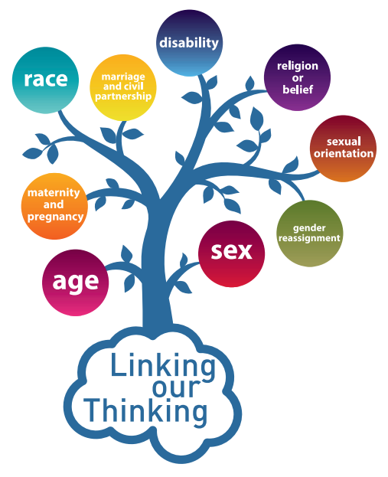

CITIZENSHIP AND BRITISH VALUES

The government aims to promote a society that embraces inclusivity. Citizenship and British values are a way of supporting this, by considering the following factors:

- How we make society work together
- Enabling people to make their own decisions
- Taking responsibility for our own lives and communities
- Promoting a sense of belonging.
- Showing respect and tolerance for all backgrounds and cultures
- Living in a democracy where your opinion counts
- Abiding by the rule of law - it is there to protect everyone
- Your individual liberty and the right to freedom of speech

As a British citizen, you have the right to:

- Human rights
- Rights of privacy
- Right to receive equal treatment
- Rights of workers
- Leave and seek re-entry to the United Kingdom at any time

As a citizen and under the Human Rights Act 1998, you have the right to freedom of expression. This includes ‘freedom to hold opinions and to receive and impart information and ideas without interference by public authority and regardless of frontiers’.

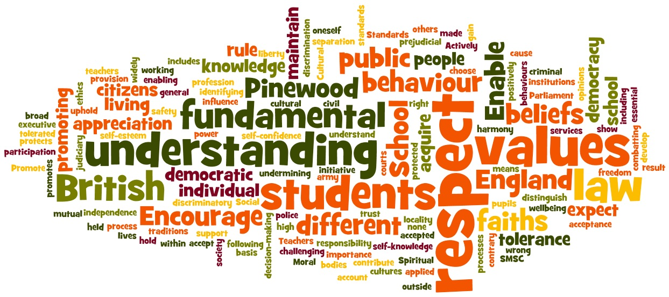

DATA PROTECTION

We take our responsibility regarding the security of personal data very seriously and comply with our legal obligations under the Data Protection Act 1998. We assure that our learners’ personal data is processed in compliance with the Act and is stored in a secure, confidential and appropriate manner.

The data will only be stored where relevant and will not be disclosed without your consent unless it’s required by law. We won’t convey or discuss your confidential or personal information with anyone outside of the company without your permission.



SAFEGUARDING

Safeguarding is the actions we take to promote the welfare of individuals and protect them from harm. A safeguarding concern is ‘anything that may cause worry about another person or contributes to a person feeling uncomfortable or unsure about the safety or welfare of someone else or themselves (including indications of potential radicalisation and expressions of extremist views)’

Safeguarding should be proactive - as well as reactive - to any safeguarding concerns and as party of our duty of care towards you, we commit to the following:

- If a safeguarding concern arises that’s about you or someone else, your trainer must share that information with their manager. Depending on the nature of the concern, this information may be shared with our National Safeguarding Champion.
- It may be appropriate for your information to be shared with an external organisation to get help for you or someone else.
- Anything relating to a safeguarding concern should not be kept private.

If you have a concern about yourself or someone else, you can always talk to your trainer, someone you trust or one of the organisations on the safety and wellbeing list at the end of this handbook.

If you do tell your trainer, they may have a duty of care to pass that information on, depending on the nature of the concern.

Here are a few examples of what a safeguarding concern may involve:

- Abuse
- Bullying and cyberbullying
- Homelessness
- Mental health issues
- Physical health issues
- Substance use
- Radicalisation
- Friends
- Family
- Neighbours

Our safeguarding lead is Gemma Nicholson. You can contact her anytime via gemma@peak-sport.co.uk.

PREVENT STRATEGY

The Prevent Strategy is part of the Government’s overall counter-terrorism strategy called CONTEST. Prevent is a multi-agency approach to safeguarding people at risk of radicalisation (being drawn into extremist groups, including terrorist groups).

As part of this strategy, we have a duty to ‘pay due regard to the need to prevent people from being drawn into terrorism’. This means we have an aim to stop people becoming terrorists or supporting terrorist organisations. The radicalisation process is similar to a grooming process for abuse and people can be made to change their behaviours and support extremist groups when they wouldn’t have chosen to do so before.

If we become concerned about you or someone else, and believe radicalisation may be happening, it may be appropriate for us to involve Channel. This is a process designed to support the individual and reverse the radicalisation process through input from different agencies.

Prevent works in the pre-criminal space (before someone has committed a crime linked with terrorism). Therefore, it’s very much about helping the individual to change before it’s too late.

If you have concerns about yourself or someone else, and think radicalisation may be occurring, you should speak with your trainer.

A lot of extremist groups post information and recruitment materials online. If you see any inappropriate web content, including speeches inciting racial or religious hatred or films glorifying terrorists who have committed atrocities, you can speak to your trainer or directly contact the National Prevent Hotline on 0207 340 7264.

HEALTH & SAFETY

We recgonise our responsibilities for providing a safe and healthy working environment for everyone that uses our facilities.

WHAT WE WILL DO FOR YOU:

- Provide and maintain a safe and healthy environment.
- Comply with all relevant legislation (eg, Health & Safety at Work Act 1974, Equality Act 2010).
- Record all accidents on an incident form along with the details of any treatment given.
- Conduct regular risk assessments on each site.
- Provide a first aid box in every office.

WHAT WE ASK OF YOU:

- To take responsibility for your own health and safety, as well as for any children you bring with you onto the premises.
- Be aware of the fire exits and safety procedures in the event of fire.
- To not to obstruct any fire escapes or emergency exits.
- To not attempt to move heavy items or equipment in the office.
- Report any incidents or potential hazards to a member of staff immediately

ACCIDENTS

If you have an accident whilst on our premises you should report this to your trainer immediately who will raise the issue with the first aid representative.

CONTROL OF SUBSTANCES HAZARDOUS TO HEALTH (COSHH)

COSHH is the law that requires employers to control substances that are hazardous to health. Common substances may be harmful and take many forms, such as:

- Chemicals
- Fumes
- Dusts vapours
- Gases
- Biological agents

Whilst on our premises, you should not attempt to clean or remove any spillage or substance that may be considered hazardous to health and should inform your trainer immediately.

SAFETY AND WELLBEING CONTACT LIST

B-EAT
Information and support for those affected by eating disorders.
www.b-eat.co.uk

BULLYING UK
Information and support for those affected by bullying.
www.bullying.co.uk

CARE QUALITY COMMISSION
For those with concerns about a child or adult and can’t contact local social services.
03000 61616 www.enquiries@cqc.org.uk

CEOP
A site for reporting inappropriate online chat or behaviour.
www.ceop.police.uk

CHILDLINE
24-hour counselling service for children and young people.
0800 1111 www.childline.org.uk

CHILDREN AND YOUNG PEOPLE’S RIGHTS
Information and guidance about safeguarding and promoting the rights and best interests of children and young people.
- In England: www.crae.org.uk
- In Northern Ireland: www.niccy.org
- In Scotland: www.cypcs.org.uk/rights
- In Wales: www.uncrcletsgetitright.co.uk

DOMESTIC VIOLENCE UK
Information and support for those affected by domestic abuse.
www.domesticviolenceuk.org
Advice Lines:
- Women: 0808 2000 847
- Men: 0808 8010 327
- LGBT: 0300 999 5428

DRINK AWARE
Information and advice about alcohol.
www.drinkaware.co.uk

EQUALITY AND HUMAN RIGHTS COMMISSION
Equality and rights information.
www.equalityhumanrights.com

FRANK
Advice and information about drugs.
0300 123 6600 www.talktofrank.com

MIND
Information and support for those affected by mental health issues.
0845 766 0163 www.mind.org.uk

NSPCC HELPLINE
For reporting concerns about the wellbeing of a child.
0808 800 5000 www.nspcc.org.uk

THE PRINCESS ROYAL TRUST FOR CARERS
Information for carers of all ages.
www.carers.org.uk

NATIONAL PREVENT HOTLINE
For reporting concerns about extremism.
0207 340 7264

RELATE
Relationship counselling and support.
0300 100 1234 www.relate.org.uk

THE SAMARITANS
Confidential support and advice for anyone in distress.
116 123 www.samaritans.org

THE MIX
Online information and guidance for young people aged 16-25
www.themix.org

STONEWALL
Information and support for lesbian, gay, bisexual and transgender individuals and communities.
www.stonewall.org.uk

THINK U KNOW
Guidance for all ages on internet safety.
0870 000 3344 www.thinkuknow.co.uk

